Artifact 1

[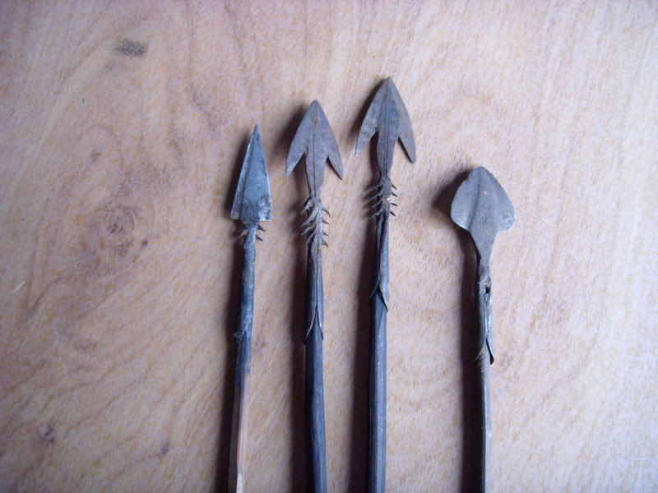](http://www.google.com/url?sa=i&rct=j&q=Poison%20tipped%20arrow%20congo&source=images&cd=&docid=3fJ28WVjOHb3FM&tbnid=m1MaJLvEdgpNuM:&ved=0CAYQjRw&url=http://www.vikingsword.com/vb/showthread.php?t=6767&ei=nj4mU562OebL0QHAxYCwCg&bvm=bv.62922401,d.dmQ&psig=AFQjCNHBLL0_p398HzHvoMLGCie47vVuJQ&ust=1395101694715817)

Artifact 2

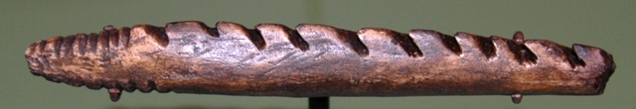

Artifact 3

[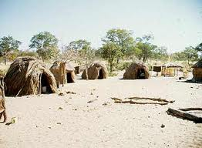](http://www.google.com/url?sa=i&rct=j&q=efe%20congo%20grass%20hut&source=images&cd=&docid=8nArISfR4sEdQM&tbnid=RayCGkYfRYbFLM:&ved=0CAYQjRw&url=http://soundingthedepths.blogspot.com/2011/02/chapter-four-baseline.html&ei=DkEmU-LFG43I0AH7-YDIAg&psig=AFQjCNG4s7Z8Jg805mO0x7Sl4YURWHLcuA&ust=1395102300473165)

Artifact 4

[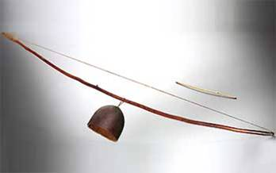](http://blogs.voanews.com/african-music-treasures/2012/08/06/siphos-newest-big-hit/)

Artifact 5

[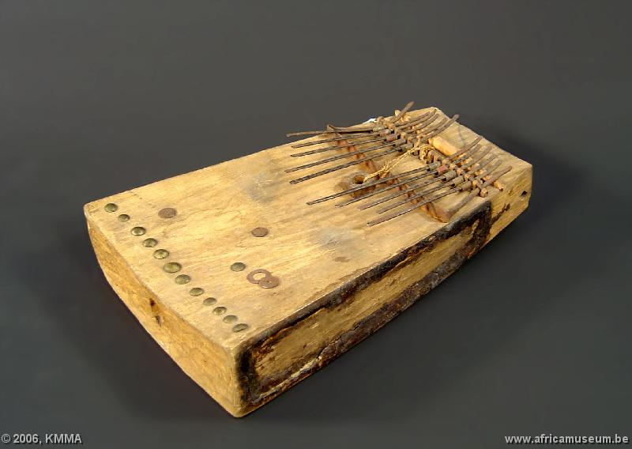](http://music.africamuseum.be/instruments/english/congo%20drc/chisanzhi.html)